Technical Report _Unveiling the ingredients for success in University Matriculation Examinations.

**Introduction.**

The joy of parents knows no bound when they see their wards University Matriculation Examination (UME) results and knowing that they did so well. While this might be the case for many parents, a greater number of parents and institutions are still battling to know the rudiments for success in UME. In this project, I dived into analyzing and deriving insight to what actually leads to success in UMEs, how parents characteristics do influence the outcome of their wards results, study time hours correlation with good or bad examination scores, effect of the availability of reading materials, the divide with rural and urban school setting, how divided in performance is the public and private schools and what effect do extra tutorial paly in the final score. To carry this out, I analyzed a dataset for the Joint Admission Matriculation result for 2024.

**Data Overview**

The dataset encompasses several critical metrics:

* Highest score obtained: 367
* **Total study Hours:** 98,000 hours
* **Best School Location:** Urban
* **Total Distance Covered to School:** 50,030km
* **Top School type by JAMB Score:** Public

**Pre-Analysis**

1. **Data Splitting**

**The data was split into two categories; Independent and Dependent Variables.**

**A. Independent Variables**

* Student ID
* Gender
* Age

**B. Dependent Variables**

* Distance to School
* Access to Learning Materials
* Extra Tutorial
* IT Knowledge
* JAMB Score
* Parent Education Level & Parent Involvement
* School Location & School Type
* Socioeconomic Status
* Assignment Completed

**Industry Type**

This dataset is for the education sector, needed to make decisions on strategies and innovation that would improve performance in University Matriculation examinations.

**Key Stakeholders**

Key stakeholders for this industry are the Ministry of Education at the State and Federal Levels, NGOs working in the area of strengthen educational system for the general public and for the girl child. Private organizations in Public Private Partnership (PPP) with Education sector. International organization.

**Value to Stakeholders**

These stakeholders are most concerned about the performance at the JAMB examinations and ways of strengthen the processes that lead to those performance.

**Potential Analysis/Questions**

1. What is the effect of Parents involvement, Socioeconomic Status and education level attained on the performance of the students (their children) in the JAMB exams?
2. What school location performed best? (Urban Vs Rural)?
3. Which gender ranked top has the best demographics in terms of their performance
4. Do access to learning materials have any significant effect on the scores obtained?
5. What is the effect of distance from school, extra-tutorial and IT Knowledge on the scores obtained?
6. What is the effect of study hours per week and assignments completed on the final examination results.
7. Is there any correlation of age with the scores obtained?
8. What is the effect of attendance rate on final performance?
9. What is the effect of the category of the school on student performance? (Public Vs Private schools)

**Potential Insights**

1. Government could use the insight from this analysis to develop strategies to help strengthen school in the Urban and rural areas through equitable distribution of resources and closing the performance gap in JAMB examination.
2. Best ways to involve parents in their student education and performance in this examination is a potential insight that could help in re-strategizing and development of policy and programs.
3. To improvement performance at the rural areas, Government may have to improve infrastructures at the school (suitable learning environment and to the school (good road network)
4. Insights on age specifics intervention that could boost performance in this examination would be derive for the analysis of the effect of age on overall score.

**In-Analysis Insights**

1. Urban locations produced top performing students with an aggregate score of 497K (57.06%) while rural setting had 374K (42.94%)
2. Public Schools outperformed their private school counterpart from an aggregated score of 641K and 229K respectively
3. The average attendance rate was 84.24 while the total distance covered was 50,030km.
4. Students that had access to learning materials performed exceedingly better than those without access where least performing.
5. Students aged 16 years were best performing with an aggregated score of 118,138 and 20 years had 94462
6. Students of parents with secondary school educational level performed top with 275K aggregated score while those with tertiary levels had 225k.
7. Highest score obtained was 367, with the female demographics outperforming their male counterparts.
8. Those students with parents who had medium involvement and medium socioeconomic status performed best from their aggregated score of 136k and 127k.
9. A total of 98,000 hours was spent weekly by the students in their studies.

**Dashboard Visualization**

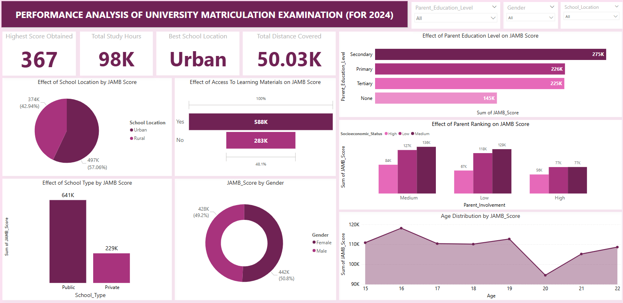

**Recommendations**

1. Government should foster an equitable distribution of digital and printed learning materials (textbook, past questions, tutorial) to enhance learning accessibility in rural areas.
2. Governments should identify and partner with NGOs to fund open access JAMB preparation platforms.
3. I recommend that government could provide subsides for tutorial groups to increase their operations at the rural areas at subsided price for rural students.
4. The Ministry of Education should identify and replicate best practices from top-performing public schools in other school to boost performance.
5. I recommend that Government should support public schools and leverage their strengths through increase investment in public education infrastructures and training for teachers.
6. Ministry of Education should capitalize on female students’ strengths to launch female-focused academic mentoring and scholarship programs to sustain their momentum and good performance.
7. Students should be encouraged to join early academic planning and preparation programs for students aged 14-15 years.
8. At the community levels, develop community-based programs that shift focus from education level of parents to quality of engagement with children, and provide guidance to help improve their involvement.
9. Government and well-placed individuals in the society should support boosting infrastructures and access to study centers in rural areas by improving transportation, availability and access to study centers in rural areas.
10. Government should publicly identify, track and rewards top performers, this would help recognize top scorers locally and help improve peers’ performance improvement.

**Observations**

1. With regards to the effect of location, students located in Urban areas (57.06%) slightly outperformed their rural counterparts.
2. The total JAMB Score from students in Urban location were surprisingly slightly higher than those in rural areas where it is envisaged that infrastructures are limited when compare to the Urban settlements.
3. The performance of Students that had access to learning materials was 51.91% when compared to those without access at 48.01%
4. Category of students whose parents had secondary education ranked top for performance in JAMB with a score of 274748, primary educated parents 225,765, Tertiary 225,011 while those without any form of education had 144,849
5. Parents educational levels did not directly present a proportional increase in scores obtained by their children.
6. Students of female gender outperformed the male counterparts with 50.8% and 49.2% respectively.
7. It was observed that students in public schools with a total score of 641134 performed better than those in private schools with 229,239 scores.
8. It was observed that there was a constant fluctuation in sum of scored obtained as influenced by student ages.
9. Student aged 16 with a total of 118,138 aggregated scores with top performers by age while students aged 20 had the least aggregated scores of 94,462.
10. The highest score obtained during the 2024 University Matriculation Examination was 367
11. A female folk ranked as the top performer with 367 score while the top male had 366.
12. A total of 98,000 study hours per week was observed as contributed by all the students that participated in the JAMB.
13. The female folks spent more hours studying when compared to the male counterpart with 50,000 and 48,000 scores respectively.
14. The average attendance rate was observed to be 84.24
15. The total distanced covered by students while preparing for the 2024 examination was 50,030km, with those in Urban areas covering a distance of 28.48 km and 21.54km for those in rural setting.
16. A breakdown of access to learning materials shows that urban located students with access has an aggregated exams score of 336,000 while rural located students had 252,000
17. The influence of parents’ involvement and socioeconomic status indicated that those students whose parents had medium involvement and medium socioeconomic status had students with the highest aggregated scores of 136,037 and 129,215 respectively.
18. High parental involvement and parental socioeconomic status were not a prerequisite for better aggregated scores in the examinations.

**Conclusion**

Parents can finally identify what is needed for success in UMEs and by implementing some or all the insights from this analysis, they can improve the performance of their wards and channel their scare resources to providing the ingredients for success. This report offers **actionable insights** for policymakers, educators, and parents. If harnessed effectively, we can close the performance gap and unlock success for students across Nigeria.